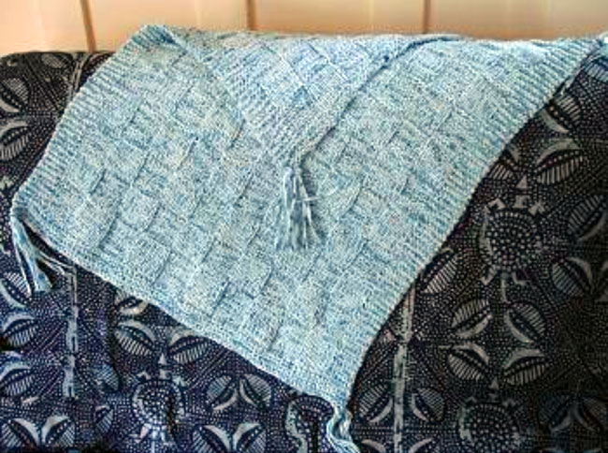
Puffin Baby Peek a Boo Blanket
Easy to Knit

Size: 24" wide x 28" long
Materials:
5 - 50 gr. balls Puffin #0202 "dotty blues"
26" or 35" US size 11 Crystal Palace Circular Bamboo or DAISY needle
The pattern is knit of alternating blocks of St st and Rev St st
- 10 blocks wide by 12 blocks long and is very easy to knit.
Instructions
Cast on 82 sts.
Work 6 rows of garter st (K all rows).
Begin block pattern (keep the edge 6 sts on each side in garter st - that is, always K the outer 6 sts on each border).
First block section (10 rows)
Rows 1, 3, 5, 7, 9: K7, P7 across row
Rows 2, 4, 6, 8, 10: K7, P7 across row
Next block section (10 rows)
Rows 1, 3, 5, 7, 9: P7, K7 across row
Rows 2, 4, 6, 8, 10: P7, K7 across row
Alternate the two block 10 row sections, keeping the outer 6 sts border sts in garter st.
Continue alternating the blocks until you are approx. 1/2 through the 5th ball of Puffin and finish the next block section. Work the last 6 rows in garter st as you did the beginning of the blanket.
Bind off loosely.
Optional: Tie tassels made with extra Puffin to the 4 corners of the blanket.
Designed and knit by Susan Druding for her grandson, Marcelo. Copyright 2006 Crystal Palace Yarns/Straw Into Gold, Inc. - We are happy to share this pattern with knitters. The pattern may be used for non-commercial personal or knitting guild use. Crystal Palace Yarns, Richmond, CA 94804. Phone: 510-237-9988, fax: 510-237-9809 or visit www.straw.com

