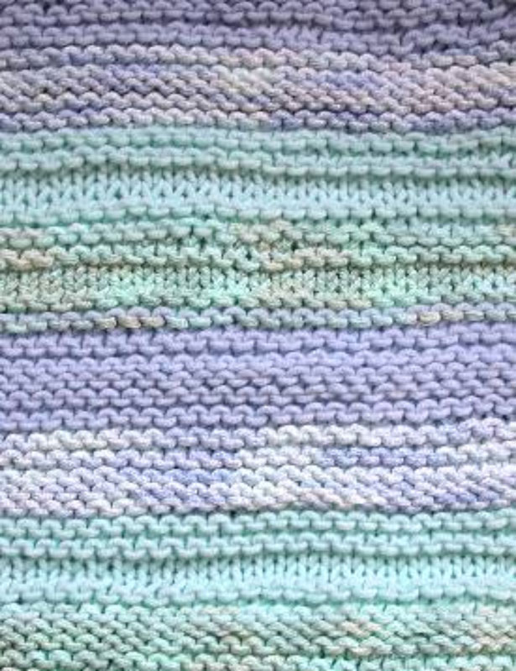
Bunny Hop & Bamboozle Baby Blanket
Easy to knit

Size:
29” wide x 32” long
Materials:
4 - 50 gr balls - Bunny Hop - 2 balls each:
A=color 2202-soft aqua & B=color 2201-powder blue
4 - 50 gr balls - Bamboozle - 2 balls each:
C=color 2304-misty greens & D=col. #2302-baby blues
Bunny Hop is a blend of microfibers and 8% angora, see colors by clicking link Bunny Hop. Bamboozle is a blend of bamboo, cotton and nylon.
Note: You could also make this entire blanket from all Bunny Hop - use 4 balls.
Needles: Crystal Palace Bamboo or DAISY Needles
Size 9 US (5.5 mm) 26” or 29" circular needle or size needed to obtain gauge
Stitches: This blanket is knit in garter st (all knit) except for occasional rows of purl to give surface texture. Tie a differently colored yarn to one edge to mark the side for increases.
The 4 yarns are rotated in order A-C-B-D in stripes of varying width. Stripes in Bunny Hop are a few rows wider than stripes of Bamboozle.
Gauge:
17 sts = 4”
Abbreviations
CO-cast on, St st: stockinette stitch, k: knit, p: purl, BO-bind off

Instructions:
Cast on 75 sts with Bunny Hop color A
Row 1: K
Row 2: K
Row 3: inc 1 st each end of row in the st one in from edge. Cont to inc every odd row until you have 125 sts on needle.
(Mark this row with a st marker or contrasting color of yarn to remember that this is the side for inc'ing.)
Rows 4-5: K
Row 6: P
Rows 7-9: Knit
Row 10: Change to Bamboozle col C and repeat rows 2-7, cont'ing to inc on all odd rows.
Row 16: Change to Bunny Hop col B and K
Rows 17-19: K
Row 20: P
Rows 21-23: K
Row 24: Change to Bamboozle col D and knit 4 rows, p 1 row, k1 row.
Continue to make stripes with the 4 different yarns in this order. Sometimes making stripes wider and sometimes narrower. In each stripe, work one row of P sts to add texture to surface.
When you reach 125 sts on needle work blanket sides straight for 15 inches.
At 15 inches, begin to dec 1 st each side in reverse of your inc sts at beginning (every odd row) until you end with 75 sts.
End with a Bunny Hop stripe and CO in Bunny Hop.
Tips:
If you always change yarn colors on an even row you will have an easier time at the edges while you are working inc and dec on the odd rows at both ends of the blanket.
When changing yarns, knit the yarns together for at least 3 sts at the edge of blanket. Cut and leave several inches of yarn hanging. After completing knitting, work these ends in through extra sts with a crochet hook to prevent unraveling.
Designed and knit by Susan Druding for her grandson, Marcelo. Copyright 2006 Crystal Palace Yarns/Straw Into Gold, Inc. - We are happy to share this pattern with knitters. The pattern may be used for non-commercial personal or knitting guild use. Crystal Palace Yarns, Richmond, CA 94804. Phone: 510-237-9988, fax: 510-237-9809 or visit www.straw.com

